OFFERS FROM February 2020 WHILE STOCKS LAST Ph.0116 236 3898
Bosch www.tebbatt.co.uk
Washing Machines e-mail : info @tebbatt.co.uk
WAB 28161GB £299.00 Star offers: ex display
WAN28201GB Please contact Siemens Fridge/Freezer KG36NAW35G
WAT28371GB for competitive prices Was £699 Now £499 as offers change
Washer Dryer Bosch Fridge/Freezer KGN36HI32
WVG30462GB £689.00 Was £1099 Now £795 Wi Fi Internal cameras
and £50.00 cash back until 17.03.20
Bosch Cordless Vacuum Cleaners BCH625K2GB £199 BBH3251GB £179
Single Oven HHF113BR0B £289.00 BCS122GB £399 - £100 cash back until 17.03.20 Bosch Village range Toasters & Kettles@ £33
Bosch Steam irons from £59
Siemens
Washing Machines
WM14N201 limited stock £559.00 (including installation.)
Washing machines and Washer dryers are £25.00 Basic installation £15 for removal and disposal of old appliance. Offered at half price with this offer sheet. £40 for £20
Please contact for competitive prices on built in appliances NEFF Bosch and Siemens we have displays of integrated appliances most working and live for demonstration.
With our Kitchens we offer: Quality kitchens for all budgets with
- Initial talk at our Kitchen Showroom
- Call out to Measure your kitchen
- We then design this on our software
- Return to showroom to see a 3D design of the kitchen design and further discussion
- Quote on above and give possible installation dates
- If acceptable we then take a deposit finish any paperwork and order your kitchen and check installation dates and finalise all the details with you.
- Your kitchen is then delivered and installed.

T: 0116 236 3898 E: info@tebbatt.co.uk W: www.tebbatt.co.uk
TEBBATT (LEICESTER) LTD. The Crossroads, Anstey Lane, Thurcaston, Leicester LE7 7JA
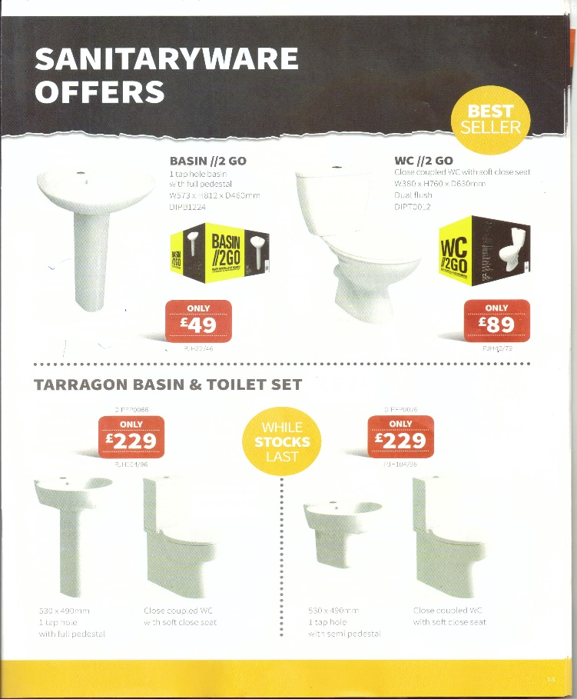
Showing some of the bathroom items we have on offer. All products subject to availability.
Full catalogue available to download at www.tebbatt.co.uk/downloads
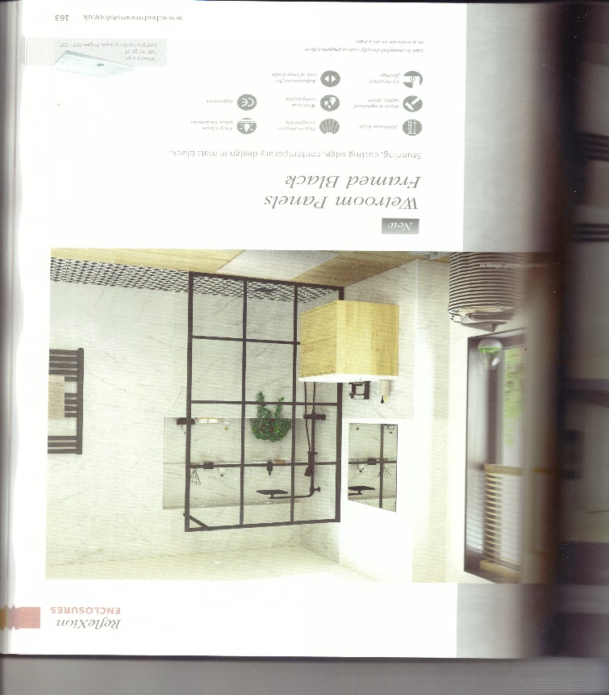
T: 0116 236 3898 E: info@tebbatt.co.uk W: www.tebbatt.co.uk

